12th ANNUAL DOUGH 4 JOE RUN

Sponsor Application
Event date July 20-22, 2017
Deadline for Sponsors is May 1, 2017
It is the Sponsors responsibility to ensure everything below is correct
to ensure proper advertising on our event T-shirts
Sponsor Business Name:
Contact Name:
Address:
City, State, Zip:
Phone Number:
Sponsor Level: |  |  |  | $250  Bronze |  |  |  | $500  Silver |  |  | $1000  Gold
E-mail Address:
T-shirt sizes:  Bronze - 2-T-shirts  Silver - 2-T-shirts & 2-camping  Gold - 4-T-shirts & 4-camping |  |  | Small Medium Large Extra Large 2 XL $10/Additional T-shirts requested
Date:
Sponsor Payment:  Executive Committee Comments: |  |  | Payment Enclosed – Yes/No Sponsored Product? Y/N
Donation Receipt sent: |  |  |  |  | 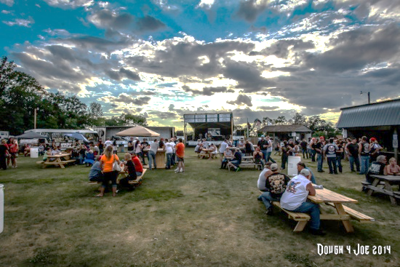
Date:
Signature:
No later than May 1, 2017
Mail application and Sponsor payment to:
Dough 4 Joe
PO Box 672
Fergus Falls, MN 56538

