12th ANNUAL DOUGH 4 JOE RUN

Vendor Application
Event date July 20-22, 2017
Deadline for Vendors is June 1, 2017
Vendor must arrive Thursday, July 20 by 12 p.m. & remain until at least July 23 at 8 a.m.
Vendor Business Name:
Contact Name:
Address:
Phone Number:
Electricity Needed? |  |  | Yes |  |  |  |  |  |  | No
Space Requested: |  |  |  | 10’x10’ |  |  |  | 10’x20’ |  |  |  |  | 10’x30’
Vendor Signature:
Date:
Space Reservation Payment $50: |  |  | Payment Enclosed – Yes/No
Additional Comments:

Executive Committee Comments:
Approved |  |  |  |  | Declined
Space: |  |  |  |  | 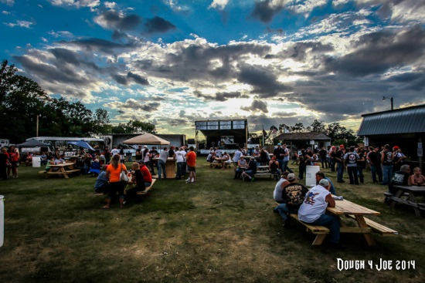
Date:
Signature:
No later than June 1, 2017
Mail application and space reservation payment to:
Dough 4 Joe
PO Box 672
Fergus Falls, MN 56538

Vendor space reservation payment is refundable upon arrival to event

